# Assignment 5

For assignment 5 we are simulating some noise effects on the Lena image. Then utilize previously covered image sharpening tools to try and return the quality of the images. For my particular implementation, I chose to add Gaussian noise and Salt and Pepper noise with a 35% chance of population. For the filters I chose the gamma correction and contrast stretching. The images in order are the original, Gaussian noise, SnP noise, Gaussian/Gamma correction, SnP/Gamma correction, then Gaussian/Contrast stretching, and finally SnP/ Contrast stretching.

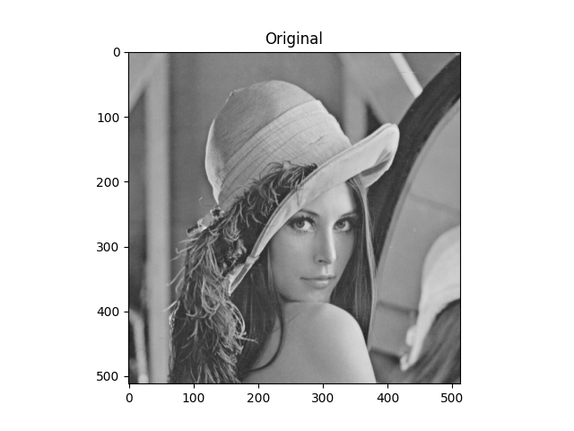

Outputs for differing tests of image accuracy:

Gaussian(1): MSE: nan, PSNR: nan, SSIM: nan

S and P(1): MSE: 15053.0266, PSNR: 6.3546, SSIM: 0.0002

Gaussian(2): MSE: 3084.128, PSNR: 13.2395, SSIM: 0.1045

S and P(2): MSE: 87.2020, PSNR: 28.7255, SSIM: 0.9947

For the analysis of the results there were a few notes of interested that came out of this exercise. First would be the nan results out of the gamma corrected Gaussian noise. This was a touch disappointing as I believe that was the most interesting resulting output. Though there were indeed large spots on concentrated noise, the overall image filtered well. I believe of the three methods observed for analysis using a mix and understanding of MSE, and SSIM were the most accurate to accounting for perception of noise. Though neither alone really did the job completely. Finally just looking at the outputs of sharpening SNP noise, it becomes obvious the difficulty some methods have in trying to eliminate error. An interesting exercise and one I wish I had taken a bit more time with!